TRD

System architecture
Clients and field devices all enter through one gateway; a small set of services share one dispatch core, with data stores and third-party integrations behind it.
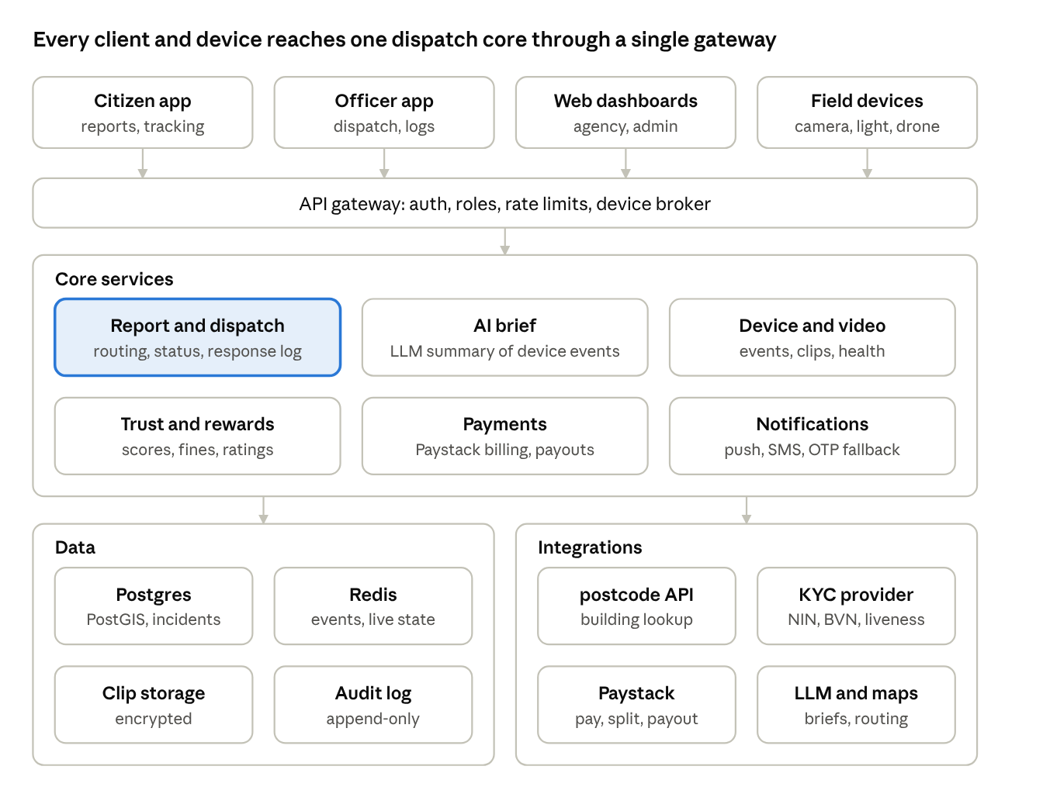
system architecture · 4 clients, 6 services, 8 data and integration parts

Technology stack
Proposed stack; each row can be swapped if your team prefers another.
Layer | Choice | Why
Citizen and officer apps | Flutter (iOS, Android) | One codebase, smooth short-form-video style animation, offline queue
Web (admin, agency, PWA) | Next.js, React, Tailwind | Responsive dashboards; PWA for users who will not install
Backend services | NestJS (TypeScript) on Kubernetes | Typed APIs, mature ecosystem, easy to hire for
Database | PostgreSQL with PostGIS | Relational integrity plus zone and distance queries
Cache, queues, live state | Redis, NATS or Kafka | Dispatch events, presence, retries
Realtime to apps | WebSockets plus push (FCM, APNs) | Live status, ETA, officer location
Device messaging | MQTT broker (for example EMQX) with device certificates | Lightweight, works on weak links
Video | RTSP or WebRTC from the gateway; clips in encrypted S3-compatible storage | Short event clips, not continuous upload
Auth | OIDC provider (for example Keycloak) with SMS OTP, email, Google, Apple, Facebook | Roles, sessions, MFA for staff
Hosting | Nigerian or African region cloud; data-transfer safeguards for any abroad service | NDPA data residency and transfer rules
Observability | OpenTelemetry, Prometheus, Grafana, Sentry | Dispatch latency and device health alerts

Dispatch engine
- Intake. The report API validates the session, trust band and payload, writes the incident, and emits incident.created within the same transaction (outbox pattern).
- Location. If the report is from a saved building, use its stored postcode record; otherwise take GPS, call the nearest-building lookup, and let the reporter confirm.
- Routing. A rules table of incident type, zone polygon and unit capability picks the primary unit and any parallel units (for example fire plus ambulance). Rules are data, editable by station heads and platform admins.
- Offer and accept. Nearest available officers get a push; if no accept within the configured seconds, the offer escalates to the commander, then to the next unit.
- Live phase. Status, location and notes stream to the incident room; the reporter sees a limited view.
- Close. Outcome code, rating request, reward calculation and audit seal.
Priority tiers come from incident type and severity, never from the trust band alone; a low-trust reporter still gets a response and a verification step for the responder.

Device and video pipeline
- Edge first. Each camera or home gateway runs motion and person/vehicle detection locally and records on-device. Only event metadata and short clips leave the property when an incident is live or a detection rule fires.
- Power and network. Cameras and street lights run on centralised household power with a battery backup and internet failover; the gateway reports heartbeat every minute so offline devices raise a ticket.
- Clip release. When an incident opens, the device service finds devices within a set radius of the building, requests clips for a time window, and stores them encrypted with a time limit. Only the assigned units can view them, and each view is logged.
- Drones. Drone requests are an incident resource like any other: the unit commander assigns a trained operator, the flight is logged with route and video, and control stays human. Flight approvals follow the aviation authority's rules.
- Street lights. Schedule plus incident-triggered brightening on the affected street.

AI pipeline
- Inputs: incident type, location record, device events and clip frames, reporter trust band, past incidents at the address.
- Model use: a vision model labels frames (people count, vehicle type and colour, visible weapon, smoke or flame); an LLM turns labels into a short structured brief with a confidence per field.
- Guardrails: AI output is advisory and labelled as such; fields below a confidence threshold are marked unverified; plate or face recognition is off unless law and agency policy allow it; a human at the agency console can edit before dispatch where time allows.
- Fail-safe: if AI or devices fail, the plain report is dispatched immediately; the brief follows when ready.
- Evaluation: measure brief accuracy against responder feedback each month and retrain thresholds.

Integrations
Nigeria postcode (NIPOST). The building-level digital postcode system has an API at api.postcode.gov.ng, keyed from the NIPOST developer dashboard. Third-party client libraries describe lookup by postcode, autocomplete from a partial code, and a nearest-building search by coordinates (within 25 m by default, capped at 250 m); the detail returned depends on the access level granted to your key (ng-postcode API notes, ng-postcode-mcp). You mentioned postcode.gov.ng/find; once you send your API details we will match the exact endpoints. Build a thin adapter with caching, retries and a fallback to GPS pin plus manual confirmation, and test accuracy on real addresses in the pilot zone before relying on it.
KYC. Use an adapter so the provider can change. Candidates for Nigeria:
Provider | Relevant capability | Source
Smile ID | Government ID checks across several Nigerian ID databases, biometric liveness, document verification | usesmileid.com
Dojah | BVN and NIN lookup, selfie-to-BVN/NIN match, liveness | Dojah docs
Youverify | NIN and BVN verification, NIN facial match, liveness SDKs, address verification | Youverify docs
Proposed choice: pilot Smile ID and Dojah side by side and keep the better one for match rate, price per check, uptime and NDPA posture. Flow: collect NIN or BVN, selfie liveness, match, then store only the verification result, a reference and masked ID (never the raw ID number).
Paystack. Use Transactions for the installation fee and one-off fines, Subscriptions for plans, Transaction Splits and Subaccounts for agency shares, and Transfers for reward and donation payouts; confirm every payment from the signed webhook, never from the client (Paystack API). Keep a ledger table as the source of truth and reconcile daily.
Others. SMS OTP provider with fallback, maps and routing, push (FCM, APNs), email.

Location filter and coverage map
The backend calls the postcode service once per level and caches each answer, so the five filters stay fast and work when the service is slow.
- The client asks our API for the next level (State, then LGA, District, Area, Building) and passes the parent the user chose.
- A postcode adapter calls the NIPOST service for that level and returns a list of id and name. Results are cached by parent id.
- Every user, station, device, job and incident stores the building's postcode and its State, LGA, District and Area ids, so list pages filter with one indexed query and need no live call.
- A typed postcode or the "Use my current location" button resolves to one building and fills all five levels.
The per-level list endpoints are not confirmed yet. They are hidden behind the adapter so only that file changes once your API details arrive.

Device status for the coverage map
Each device keeps one status: online, low_power, offline, needs_repair, tamper. A building with no device is shown as not covered. The status comes from device heartbeats, with these defaults to be tuned: offline after [n] minutes without a heartbeat, low power below [n]% charge, tamper on a tilt, lens-cover, cable-cut or enclosure-open event. A status change publishes a device.status event to the admin:devices channel; tamper also alerts the nearest station and the platform team.
The maps read buildings and devices by bounding box and by the filter ids above, and group nearby markers when zoomed out.

Duplicate reports (one incident, many reporters)
Many people can report the same event. The system keeps one incident and attaches every report to it, so the agency gets one dispatch and every reporter sees one status.
- Send first, merge after. A report always creates a record and dispatches at once if nothing matches. Matching runs on the server straight after, so a wrong guess never delays help.
- Match. Candidates are open incidents whose type is the same family, whose building shares the postcode or is within [100] m, and which opened within [15] minutes (longer for fire). Same building and same type merges automatically. A nearby building or a related type is only suggested to a dispatcher. Fire and robbery at one building are linked, not merged.
- Attach. The new report becomes a child of the incident. No new offer is sent. Each added report, and each device event from the building, can raise priority.
- Brief. The AI brief is rebuilt from all reporters' answers and the building's device clips, and stays advisory.
- Status. Every reporter follows the same incident channel, so all see the same timeline.
- Fines and trust. Joining an incident that officers confirm is never fined as a false alarm and raises the reporter's trust band. A fine applies only to a report that officers mark false on its own.
- Undo. A dispatcher can split a wrong merge or merge a suggested duplicate. Both are logged.
- Abuse. One person's repeat reports on the same incident count once. Rate limits apply per person.
The citizen app shows an "Already reported nearby" screen when a match exists, showing the area and status but not who reported or the exact building. The reporter can confirm it is the same incident and add details, or say it is different, which starts a separate incident. The station incident page lists every report and a Possible duplicates card.

